**Dataset for training:-**

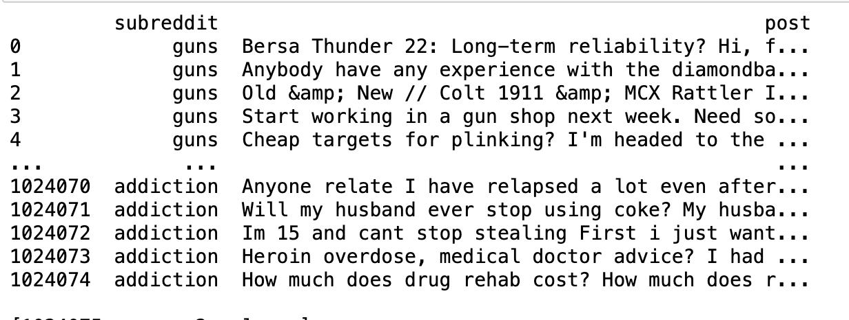

->The dataset titled “Mental Health Support Feature Analysis,” available on Kaggle, offers a comprehensive collection of features derived from mental health support data.

-> Focused on analyzing features related to mental health support across various themes, including topics like alcoholism, stress, depression, and more.  
  
**Applications:-**

Train models to categorize mental health issues based on features.

Example: Build a classifier to detect alcoholism-related conversations.

Usage: Design applications that augment, not replace, professional mental health care.